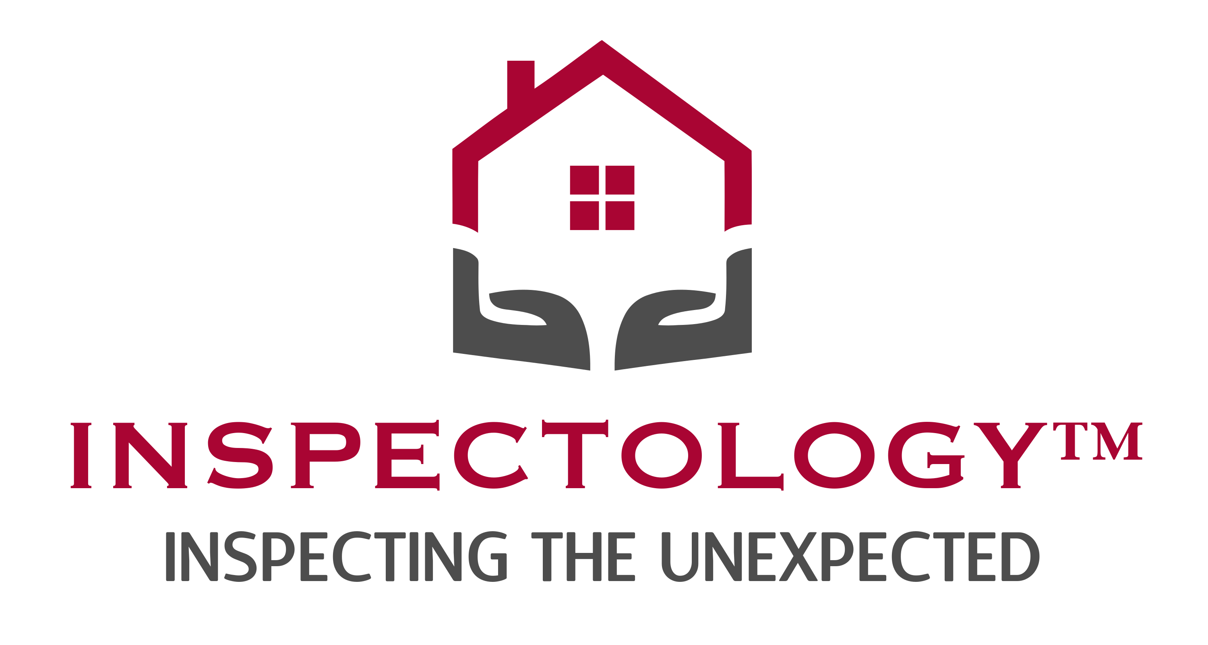

Job profile: Inspector

Job Standards

Primary Objectives
- Provide detailed information through written and verbal communication regarding the findings of inspection
- Ensure client receives unbiased yet neutral feedback regarding findings
- Build trust with clients and real estate agents using a calm demeanor, consistency, honesty, thoroughness and communication
- Produce consistent services, both written and verbal
- Communicate value to client regarding additional services that are provided
- Communicate as a team player within the organization regarding opportunities of improving service, value and product offerings

Regular Work Activities
- Perform residential home inspections
- Perform termite inspections
- Perform add-on services inspections: mold, thermal and sewer cameras
- Attend ongoing training in-house and field
- Produce training materials within training meetings within teams
- Role-play training

Management Responsibilities
- No direct management duties

Key Skills
- Be teachable/coachable
- Strong attention to detail
- Strong verbal communication skills
- Exceptional organizational skills
- Well-developed empathy for working with stressed clients
- Ability to actively listen and remain calm under pressure in confrontational situations
- Ability to interpret and analyze data
- Concern about doing things the “right way”

People Contacts & Interaction
- Inspector Division Manager- bi-monthly
- General Manager – monthly
- Field Leader – weekly / bi-monthly

Compensation
Salary plus commission or…
Commission only

Job Requirements

Experience / Training
- Licensed in the field - Preferred
- Inspection experience – Preferred
- Customer service/relations – Preferred
- Building experience – Beneficial

Behavioral REquirements

Preferred AVA
V1 High Assertiveness (?)
V2 Mid Sociability (?)
V3 Mid Calmness (?)
V4 High Conformity (?)

Narrative
We are looking for a detail-oriented person who is a great communicator, connects with people, and has the ability to learn the technical aspects of home inspections. While being licensed and having industry experience is beneficial, it does not limit the scope of hiring for this position. This position also requires someone who is comfortable with growth and change and is willing to learn and adapt to an ever-changing industry that continually requires higher levels of competencies. An attention to detail is critical as is the ability to communicate very well both in writing and verbally. Punctuality is also required.
We are looking for a self-driven, results-driven, teachable team players who thrives in an environment of teaching and motivating. We seek someone who is not afraid of change or a challenge, is able to lead by example, and does not mind working in the trenches when the need arises. This person will also handle the more difficult and delicate matters with finesse, professionalism, and expertise. This person holds a high degree of self-accountability.
Sales of services and acquiring client reviews are obtained with an engaged and motivated inspector. The inspector has a willingness to teach others and brings a positive approach to challenges faced in the field.

